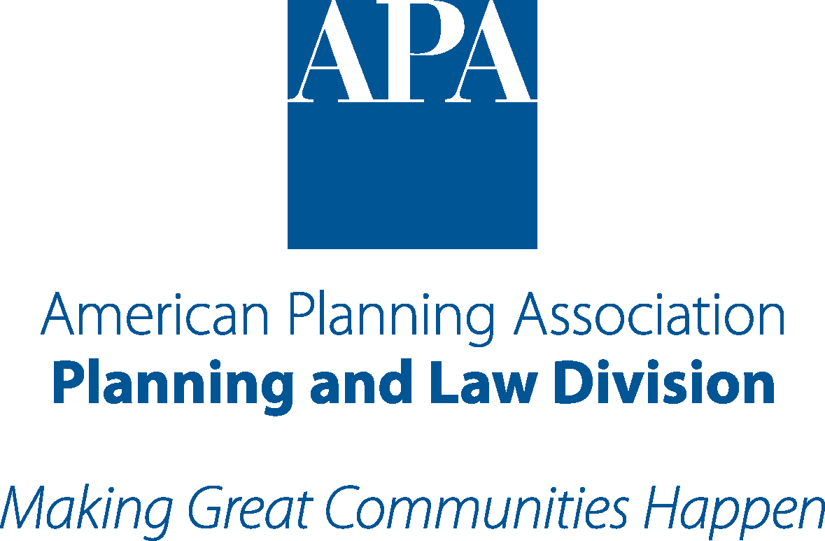 Planning and Law Division of the American Planning Association
Daniel J. Curtin, Jr. Fellowship Application (2016-2017)
Applications must be received by September 15, 2016.
Please Type Or Print Clearly
Personal Information
Name Last First Middle |  |  | Citizenship
Home Address | State | Zip Code | Home Phone
Email Address |  | Web Site
Employer/Present Position
Immediate Supervisor
Office Address | State | Zip Code | Office Phone
Education
UNDERGRADUATE INSTITUTION (Name and Location) |  |  | Graduation Date
Major and GPA |  |  | Degree
POST-GRADUATE INSTITUTION (Name and Location) |  |  | Graduation Date
Major and GPA |  |  | Degree
POST-GRADUATE INSTITUTION (Name and Location) |  |  | Graduation Date
Major and GPA |  |  | Degree
Miscellaneous
Previous Awards and Fellowships
Publications, including books, special articles, etc.

To Be Submitted With Application
(use 8 ¹/₂” x 11” paper throughout – put your name on each page)
Personal Statement:  ◻ A typed statement, not to exceed three (3) single spaced pages, describing your interest in a career in planning and the law, and describing what impact the student wants to make in the planning and law field.  Resume:  ◻ A resume of work experience and background. | Transcripts:  ◻ Unofficial transcript of current course of study sent with electronic application; Official transcript sent under separate cover via mail.  References:  ◻ One (1) letter of recommendation in support of the student's application and career goals.  Enrollment Verification:  ◻ Verification of student enrollment (for current students) or a copy of an acceptance letter from a PAB accredited graduate planning school or a law school (for incoming students).
Certification  I have examined the entire application and all documents attached. I certify that to the best of my ability, knowledge and belief that this PLD Daniel J. Curtin Jr. Fellowship application package is true and all representations herein are accurate statements of fact(s).  Signature of Applicant ____________________________________________  Name of Applicant:_______________________________________________ |  | Date:__________________
Please indicate how you learned about this program (check one):
◻ PLD Promotion ◻ PLD Website
◻ School/University Office ◻ Other (please list)_____________
DEADLINE
The deadline for the fellowship program is September 15, 2016. All application information must be received by the PLD Fellowship Administrator by that date. Applications must be submitted electronically in a single PDF file and emailed to Evan J. Seeman, Esq., Secretary/Treasurer of the PLD, at eseeman@rc.com. PDF files should be titled in accordance with the following example: “JDoeCurtinFellowApp2016.” Additionally, official transcript must be received by September 15, 2016 at the following address:

Evan J. Seeman, Esq
Robinson+Cole
280 Trumbull Street
Hartford, CT 06103

Please Note:
Incomplete applications will not be reviewed by the PLD Committee.
To verify the status of your application, send a request to eseeman@rc.com.

