
All APA-Kansas members are invited to nominate a person, group, institution, or organization for one of the APA-Kansas Chapter Awards. Awards are made in the following categories:
- Ad Astra Award, recognizing an individual or institution making a significant long-term contribution to the field of planning in Kansas.
- Pioneer Award, recognizing creativity and innovation in using planning to meet a community need or solve a public problem, in urban or rural areas.
- John Keller Award, recognizing successful implementation of a tool, practice, program, project, or process accomplishing positive change as a result of planning.
- Sodbuster Award, recognizing an individual, appointed official, or an elected official who has advanced or promoted the cause of planning in the public arena.
- New Horizon Award, recognizing a student or student group that pushes the boundaries of planning in creative and innovative ways.
- Meadowlark Award, recognizing an individual, project, or program creating greater awareness of the value of planning to improving a community’s quality of life.
- Great Places in Kansas, recognizing a place of exemplary character and quality that embodies a visionary planning approach.
APA-Kansas Chapter Awards
Recognizing Great Planning in Kansas


The City of Overland Park received the 2024 Pioneer – Urban and Meadowlark Awards

Help us celebrate great planning in Kansas by nominating an outstanding planning effort. Award nominations are due by 5:00 p.m., August 3, 2026.
General Awards Information
- Entries must include a two-page statement that specifically addresses the criteria in the order requested under each category.
- Entries must include the end product (plan, project, etc.) and any necessary supporting documents.
- Entries must include at least one, but no more than three one-page letter(s) in support of the entry. The letter(s) should offer support for the value of the nominated effort and not written by the nominator of the submission, by the nominated individual, or by anyone who directly worked on the project.
- Entries receiving awards become the property of APA-Kansas and will not be returned.
- Entries must be submitted electronically. One complete application (include all supporting documents) must be submitted in PDF format no later than 5:00 PM on August 3, 2026.

Recipients will receive their awards at the 2026 Quad State Planning Conference, October 28-30 in Kansas City. Recipients will receive an engraved plaque and features on the APA-Kansas website and the APA-Kansas newsletter.
The Awards Committee is under no obligation to grant an award in any category or may elect to move a nomination to a different category. The Awards Committee will notify nominators of submissions in mid to late August. Official announcements of submissions receiving awards will be made after all nominators have been notified.


Award Categories & Criteria

Ad Astra Award - Leadership
Recognizes an individual or institution that has made a significant long-term contribution to the field of planning in the state of Kansas. The impact of their work extends beyond the geographic boundaries of their place of business and takes the profession of planning to a higher level.
Eligibility: Candidates must be nominated and cannot apply.
Criteria:
- Enhancement of planning profession – Describe how the nominee has shaped the profession statewide.
- Significant Contribution – Identify projects or policies this person or institution has made over an extended period to promote planning.
Note: This recognition is reserved for rare occasions and may not be awarded annually.

Pioneer Award (Urban or Rural) – Best Practice
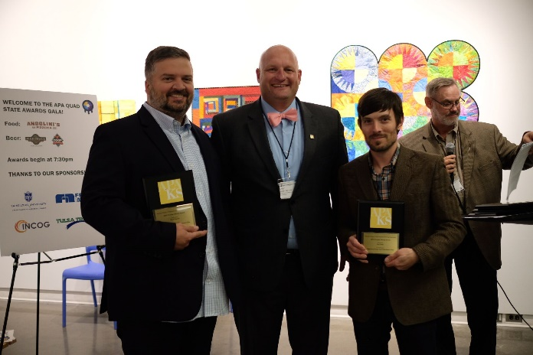
Recognizes a comprehensive, neighborhood, sector, corridor, or transportation plan that has demonstrated creativity and innovation to meet a community need or solve a public problem. The solutions must be sustainable, promote diversity and inclusion, have demonstrated public support through cutting-edge outreach, and can be implemented. The Pioneer Award includes two subcategories: Urban and Rural.
Eligibility: Candidates can apply or be nominated.
Criteria:
2019 Pioneer Award - Rural presented to the City of Emporia & Lyon County
- Planning Solution – Identify the problem or need and describe how planning played a role in designing a solution.
- Creative yet practical – Describe the original thinking involved with the solution and demonstrate public involvement and support.

John Keller Award – Implementation
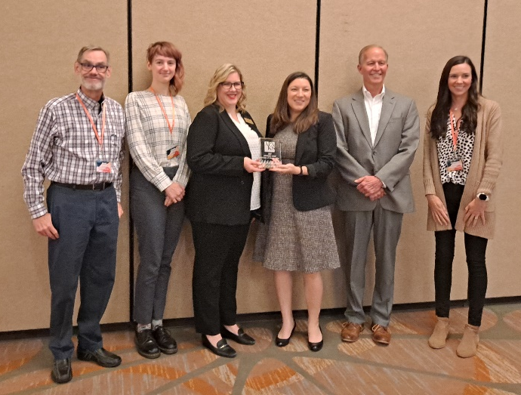
Awarded in memory of John Keller, PhD, FAICP, recognizes the successful implementation of a tool, practice, program, project, or process accomplishing positive change as a result of planning.
Eligibility: Candidates can apply or be nominated. Nominated efforts must have been in continuous effect for a minimum of three (3) years, not including the time for plan preparation and approval.
Criteria:
- Originality and innovation – Describe how the implementation effort represents a visionary approach or innovative concept to address specific needs. Illustrate how the implementation effort has potential application for others and furthers the cause of good planning.
2023 John Keller Award - presented to the Kansas Department of Transportation
- Effectiveness and results – Indicate the level of consistency of this implementation effort since its start. State how the implementation effort addressed the need or problem that prompted its initiation. Be specific about how the results have made a difference in the lives of people affected.

Sod Buster Award – Advocacy and Awareness
Recognizes an individual, appointed official, or an elected official who has advanced or promoted the cause of planning in the public arena. Those nominated may include engaged citizens demonstrating outstanding leadership in a community, region, or state; members of planning commissions, boards of zoning appeals, economic development boards, environmental or historic preservation councils, or other appointed officials; or elected officials, whether holding office at the local, regional, or state level. Nominations may also include the more nontraditional roles of citizen activists or neighborhood leaders.
Eligibility: Candidates cannot be self-nominated and cannot earn their living as planners.
Criteria:
- Support of planning – Illustrate how the nominee’s work has increased the understanding of the planning process. Indicate how the nominee has shown a clear understanding of, and support for, the role of planners in public life.
- Effectiveness and results – Describe the extent that the nominee has been effective in formulating and implementing plans and ideas in support of good planning. Identify the level of influence and effectiveness achieved by the nominee within different segments of the community.

New Horizon Award (Individual or Team) – Planning Principles
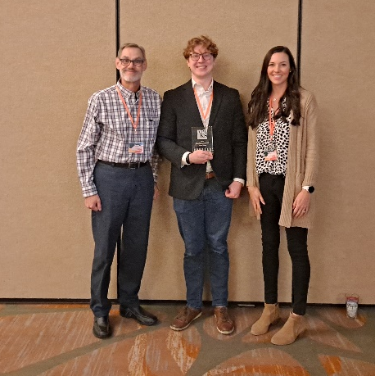
Honors a student or group of students who have illustrated excellence in planning with attention to comprehensive planning principles and the planning process.
Eligibility: These awards are open to any student or team student project/paper/plan produced while the student(s) were enrolled in a graduate-level planning program during the summer 2025 through spring 2026 semesters.
Criteria:
The applications should focus on how the nominee’s achievement illustrates excellence in planning with attention to comprehension of planning principles and the planning process. In addition, the nomination should particularly demonstrate how the project pushes the boundaries of planning in creative and innovative ways. However, in being creative, the project should continue to be feasible. By being innovative yet viable, the winning projects will contribute to advancing the field of planning.
Tyler Tripp received the 2023 New Horizon Award

Meadowlark Award – Public Outreach
Recognizes an individual, project, or program creating greater awareness of the value of planning in improving a community’s quality of life such through efforts showing how planning can make a difference, programs to teach children about planning, neighborhood empowerment programs, and use of technology to expand public participation.
Eligibility: Candidates can apply or be nominated.
Criteria:
- Originality and transferability – Demonstrate how the new ideas and tools address a demonstrated need for planning information or education within the community. Illustrate potential application for others.
- Participation – Explain how various public interests were involved, in particular efforts to solicit input from those historically left out of the planning process. Demonstrate the benefits of increased community awareness.

Great Places in Kansas
Recognizes a place of exemplary character and quality that embodies a visionary planning approach.
Eligibility: Candidates can apply or be nominated. The municipality in which the place is located must endorse nominations.
Criteria:
- Achievement – Describe the place. What makes it a great place and why is its creation or preservation special?
- Originality and innovation – Describe how the place embodies a visionary approach or innovative concept to address specific needs. Explain how the use of the planning process enabled or supported the creation or preservation of the place.

Submitting a Nomination
A complete awards nomination consists of:
- Completed awards nomination cover sheet
- A two-page statement that answers the awards criteria in the order requested under each category above.
- A copy of the end product (plan, project, etc.) and any necessary supporting documents.
- One to three one-page letter(s) in support of the nomination. The letters should offer support for the value of the nominated project/person and may not be written by the nominator, by the nominated individual, or by anyone who directly worked on the project.
Awards nominations must be submitted electronically and should be in pdf format. Awards nominations should be emailed to Scott Knebel, AICP, the awards committee chair, at scottknebel@derbyks.gov. If documents are publicly available online, the nomination may supply a link to the document instead of submitting the document electronically. If files are too large to email and not available online, please provide the document via a shared online folder (Dropbox, Google Drive, etc.).

Questions
Any questions about the awards categories, criteria, or submission requirements may be directed to Scott Knebel, AICP, at scottknebel@derbyks.gov or (316) 788-6632 ext. 1236.

2026 APA-Kansas Chapter Awards
Award Nomination Cover Sheet
Award Category
Ad Astra Award Pioneer Award (Rural)
New Horizon Award (individual) Pioneer Award (Urban)
New Horizon Award (group) Sod Buster Award
John Keller Award Great Places in Kansas
Meadowlark Award
Nominee
Nominee Name of Project
Mailing Address
Email Telephone
Nominator
Nominator Organization
Mailing Address
Email Telephone
Nomination Checklist
Awards Cover Sheet
Nomination Statement (maximum of two pages)
Final Product
Letters of Support (maximum of three letters; one page each)

Nominator’s Signature Date
Nomination Deadline: 5:00 PM, Monday, August 3, 2026.

