How to Plan a Local Site Visit
A site tour of a development or project area for local elected officials is a way to show the great work that you do and how important public funds are to your projects. The best time to plan a site visit is when they are home in their districts. It may seem like a lot of work, but never fear, APA’s Policy team put together the following checklist of things to do before, during, and after you host a local site visit:
Before the Event
- Determine the location(s) of the event: Want to educate a legislator about placed-based solutions to affordable housing or Complete Streets? Host an event or show them a place that highlights the approach you’re advocating for.
- Ask partners to join in the event: Identify like-minded local organizations that you have worked with on this or similar projects. Partners can be helpful in providing additional resources ranging from staffing and transportation to promoting and pulling additional partners in. Make sure to identify point of contacts for each partner.
- Promote your event internally to your own staff and externally to local partners, planners, leaders in the community, your APA Chapter and Section.

Inviting Elected Officials
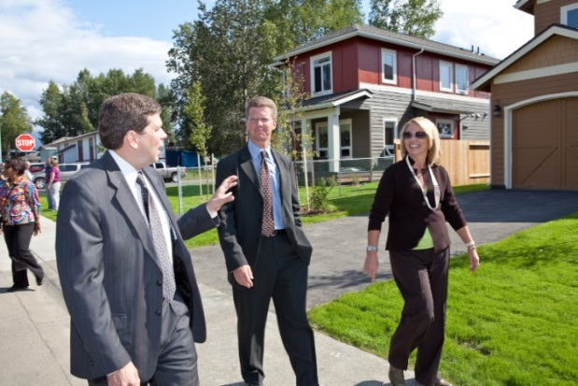
- Plan Ahead: Legislators’ calendars fills up several weeks in advance. Make your initial scheduling contact with the office at least three weeks before the event.
- Call the state/district office and ask who handles the scheduling when the legislator is at home.
- Submit an official, formal invitation outlining the specific details of the event; (when, where, who, what)
- If possible, be flexible with potential dates and times.
- Follow-up frequently: Schedulers get hundreds of requests a month. Make sure you’re in regular contact with the office so your request doesn’t get buried. Follow-up with a call if needed.
- Send any informational materials to the office in advance of the event.
- Make sure to get a day-of contact for whoever will be assisting the congressperson at the event.
- If the congressperson is unable to attend an event in August, consider working with the scheduler to plan an event during another upcoming recess in September or October.

During the Event
- Provide a one-page handout or informational materials about the project or site for all attendees.
- Take pictures and share them on your social media channels (i.e. Facebook, Twitter). Tag or mention elected leaders, partners, and APA Chapters as appropriate.
- Conduct on-site interviews with event attendees. Have an elected official on your site visit? Record a quick interview with them on your cell phone to use for post-event coverage later (Optional)

After the Event
- Thank attendees for taking part in the event. Make sure to send separate follow-up emails to partners and legislators and their staff. Record the steps you took to plan a visit to reflect on for future site visits.
- Tell your event story: Don’t forget to share the good news about your site visit. Write a wrap up blog post or article for your chapter newsletter about the event. Pictures always help tell a good story.

